Frankie's FPIES Wordsearch
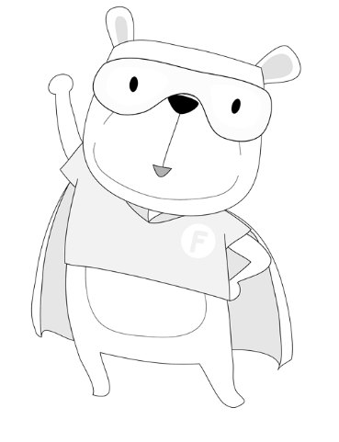
Frankie has hidden some words, can you find them?
Website: fpiesuk.org Twitter: @FPIESuk JustGiving: justgiving.com/fpies
Z | C | E | F | N | S | P | U | F | X | X | I
P | U | Z | E | G | T | P | F | P | F | M | M
Y | A | F | R | B | E | D | T | I | S | J | F
Q | K | N | N | J | S | G | P | E | J | Y | R
F | I | G | H | T | I | N | G | S | X | Y | A
U | H | G | O | F | R | I | E | N | D | S | N
B | W | C | R | C | B | X | Q | T | J | D | K
Z | W | S | Y | I | A | S | F | N | G | A | I
F | A | C | Q | B | L | Q | Y | V | B | Z | E
B | J | A | S | U | P | E | R | H | E | R | O
Q | D | I | A | M | Z | R | C | M | A | X | D
Y | C | H | Q | B | T | X | S | C | R | I | Q

BEAR | FPIES
FERN | FRANKIE
FIGHTING | FRIENDS
SUPERHERO

