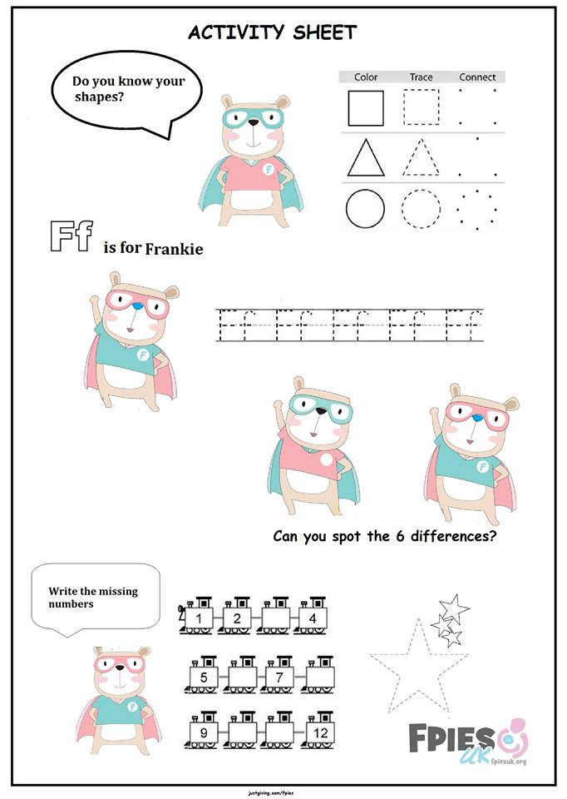Activity Sheet

Website: fpiesuk.org Twitter: @FPIESuk JustGiving: justgiving.com/fpies